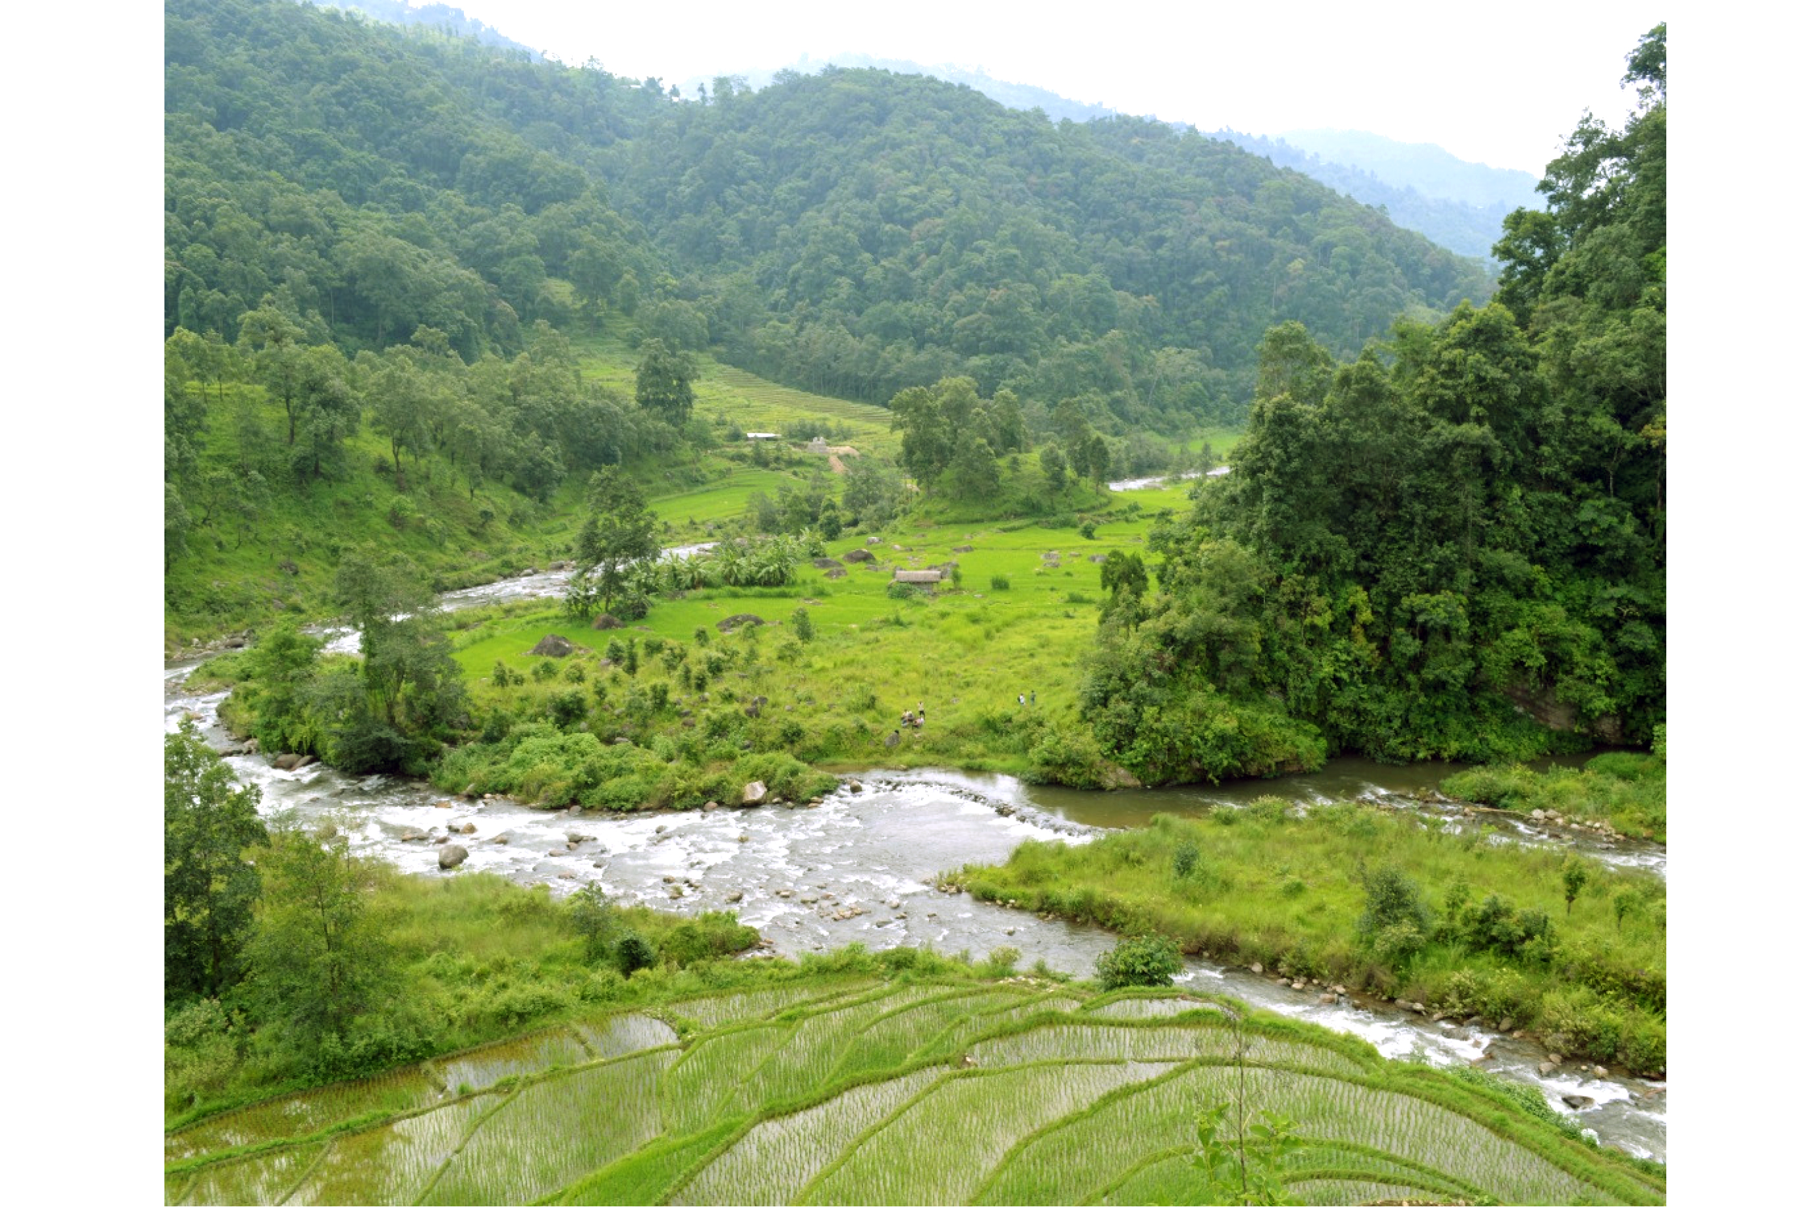

Puwa Khola-One Hydropower Limited was founded on the 16th day of Poush in the year 2065 with the primary objective of developing Hydropower Projects. The company successfully commissioned a 4MW Hydropower plant in the Ilam District on the 23rd day of Ashoj in the year 2074 BS.

In addition to this achievement, Puwa Khola-One Hydropower Limited has also undertaken the development of the Aayu Malun Khola Hydropower Project. Geographically, this project is situated within the latitude range of 27°21'28" N to 27°23'46" N and the longitude range of 86°24'28" E to 86°26'36" E. Physiographically, the project area is in the Higher Himalayan region and spans altitudes ranging from approximately 930.1 meters above mean sea level (amsl) to 1457 meters amsl.

Accessibility to the project area is facilitated by a well-established route. One can reach the project site from Kathmandu to Ramkot via a blacktopped road and then continue on a gravel road from Ramkot to the Powerhouse. Then earthen road from powerhouse to Intake.

.

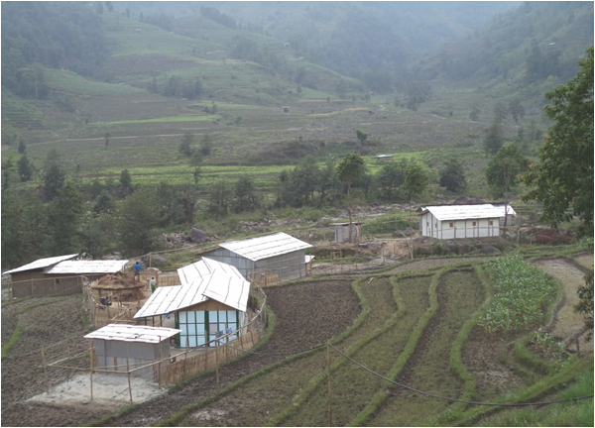

Temporary Office and Staff Residence

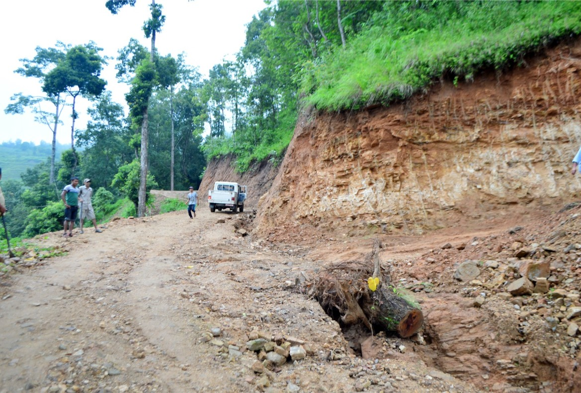

Access road constructed in parallel to the headrace pipe align- ment joining the headworkand the powerhouse area for the ease of construction work.

Aayu Malun Khola Hydropower Project(AMKHP) has concluded its PPA with Nepal Electricity Authority (NEA) on Falgun 1 2078 B.S. (22nd Feb 2022)for the power potential of 21 MW. The project’s Initial Environmental Examination (IEE) for the installed capacity of 21 MW was carried out by Puwa Khola-1Hydropower Ltd. and was approved by the Ministry of Energy (MoEn) in Baishak 13, 2076 B. S. Generation license of the project has already been issued on 14 Mangsir 2079 B. S. (License no.: Bi. Bi.Bi Bi 079/80 Bi.U. 383) by the DoED.

The financial closure agreement process is ongoing with Citizens Bank International

Head

Office:

Durga Bhawan 2nd Floor

Anamnagar-29, Kathmandu

Tel: 01-4102907,

[Email: puwakholahydropower@gmail.com](mailto:akholahydropower@gmail.com)

Malunhydro@gmail.com

Puwa Khola

One Hydropower Ltd.

Aayu Malun Khola Hydropower Project (21MW)

Registration No.: 59039/065/066

**ABOUT COMPANY**

**SALIENT FEATURES**

**CAPITAL STUCTURE**

Registration No. : 59039/065/066



Project Cost : NPR.730 Million

%)

Authorized Capital : NPR.350 Million Issued Capital : NPR.292 Million Paid up Capital : NPR.60 Million

Company Registration Date : 2065/9/16

Registered at Department

of Industries :1407/107/2068/069

Permanent Account Number

(PAN) : 303414179

Power Purchase Agreement

(PPA) : 2078/11/01



Generation License

Obtained on : 2079/08/14

**MISSION:**

PuwaKhola-one is public hydropower company with the aim to promote hydropower in Nepal. We are a team of experts and young talents bringing excellence and innovations in the projects. We believe this will help us to bring sustainable invest- ments and add more projects in directed time.

**VISION:**

Become an innovative and key Hydropower devel- oper in Nepal.

**BOARD OF DIRECTOR**

**General**

|  |  |  |  |
| --- | --- | --- | --- |
| Chairman: | Mr. GyanendraThapa | Transmission Length :18.6km  Voltage : 132Kv  Type of Circuit : Single Circuit up to Tingla  Proposed Interconnection Point : Tingla , Solukhumbu | Aayu Malun Khola Hydropower Project (AMKHP) is |
| Managing Director:  Director : | Mr. Kadam K.C.  Mr. Madhukar Garg | Run-of-River (RoR) type project located in Malun Rural Municipality(MRM) ward no 5,6 &7 |
| Director: | M | Of Okhaldhunga district, Province no 1 |
| Independent Director: | Mr. | Nepal.The transmission passes through MRM 5&8, Siddicharan |
|  |  |  |
|  |  | . |

Country : Nepal

District / Development Region : Okhaldhunga Solukhumbu Province 1 ,

VDC :Prapcha, Srichaur, Rangadip, Patale, Bigutar, Jantarkhani, Kerun, Tingla

Type of power plant : Run off the River Design Discharge : 4.52 m3/s Installed Capacity : 21MW

Annual Energy : 112.59 GWhr

Diversion weir : Permanent Concrete

Crest level : 1457.00 m

Length : 35.00 m

De-sander : 2 Nos, 85 m*5.5m*3.01m

Head Race pipe : 1.6 m dia, Length-577 m

Tunnel Lenngth : 1876m

Surge Pipe Length : 48.54 m

Penstock Pipe :1620m

Power : Surface with Outdoor Switchyard

Turbines : 2 Units, Pelton

Rated Capacity : 21MW

Net Head : 511.58m

Generators : 3-Phase AC Synchronous

Transformer : Step Up Power Transformer

Rated Capacity of Transformer : 8650 kVA (3+1)

Terminal Point : To NEA Substation at Tingla

Construction Period : 3 Years

Transmission line :

**PROJECT FINANCING STRUCTURE**

Total

**FINANCIAL HIGHLIGHTS**

Loan : NPR.438 Million (60

Equity : NPR.292Million (40

IRR on Equity : 16.54

B/C Ratio : 1.22

1st year Revenue :

Average Revenue :

**Investment on Aayu Malun Khola Hydropoer Project a wise investment.**

● The immediate development in energy sector is must for the country to prosper. This view has struck our promoters and execution team.

● Infrastructures already have been developed

accordingly.

● Waiver of Corporate Tax on the earning as per

prevailing law in country.